**4 bit ALU**

**IMPLEMENTATION VHDL**

**Name : Md. Khairul Hasib   
ID: 2015-2-60-105**

**Cse 360 (sec 3)**

**module fulladd**

(sum1,c_out,a1,b1,c_in1);

output sum1,c_out;

input a1,b1,c_in1;

wire s1,c1,s2;

xor(s1,a1,b1);

and(c1,a1,b1);

xor(sum1,s1,c_in1);

and(s2,s1,c_in1);

xor(c_out,s2,c1);

endmodule

**module mux4to1**

(out,i0,i1,i2,i3,s1,s0);

output out;

input i0,i1,i2,i3;

input s1,s0;

wire s1n,s0n;

wire y0,y1,y2,y3;

not(s1n,s1);

not(s0n,s0);

and(y0,i0,s1n,s0n);

and(y1,i1,s1n,s0);

and(y2,i2,s1,s0n);

and(y3,i3,s1,s0);

or (out,y0,y1,y2,y3);

endmodule

**module ALU**

(output result, output cout, input a,b,input cin,binvart,op1,op2);

wire w1,w2,w3,bx,binx;

wire a0,a1,a2,a3;

and(a0,a,b);

or(a1,a,b);

not(bx,b);

not(binx, binvart);

and(w1,b,binx);

and(w2,bx,binvart);

or(w3,w1,w2);

fulladd stage1 ( sum1,c_out,a1,w3,cin);

mux4to1 stage2(result,a0,a1,sum1,a3,op1,op2);

endmodule

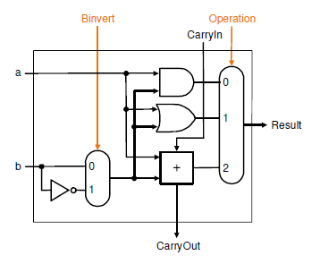

**module ALU4bit**

(output [3:0]result, output cout, input [3:0]a,b,input cin,binvart,op1,op2 ,output zero,overflow);

wire cout0,cout1,cout2,cout3,t1;

ALU alu0(result[0],cout0,a[0],b[0],cin,binvart,op1,op2),

alu1(result[1],cout1,a[1],b[1],cout0,binvart,op1,op2),

alu2(result[2],cout2,a[2],b[2],cout1,binvart,op1,op2),

alu3(result[3],cout3,a[3],b[3],cout2,binvart,op1,op2);

or(t1,result[0],result[1],result[2],result[3]);

not(zero,t1);

xor(overflow,cout2,cout3);

endmodule

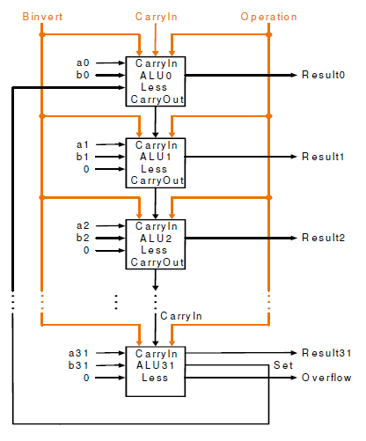

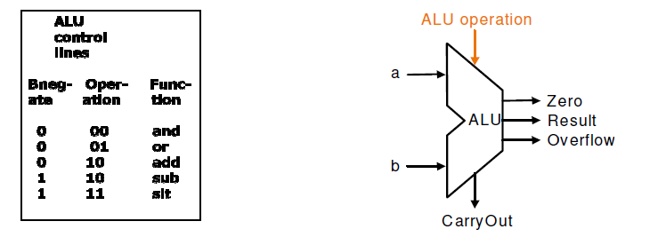

**module stimulus;**

wire [3:0] result;

Wire c_out, zero, overflow;

reg [3:0] a,b;

reg binvart, op1, op2;

alu_4_bit (result, c_out, zero, overflow, a, b, binvart, op1, op2);

initial

begin

$monitor($time, “result[0]=%b, result [1]=%b, result [2]=%b, result [3]=%bb\n”,result[0], result [1], result [2], result [3]);

a[0]=1;a[1]=0;a[2]=0;a[3]=0;

b[0]=0;b[1]=0;b[2]=1;b[3]=1;

#5 binvart=0; op1=0; op2=0

#5 binvart=0; op1=0; op2=1;

#5 binvart=0; op1=1; op2=0;

#5 binvart=0; op1=1; op2=1;

#5 binvart=1; op1=0; op2=0;

#5 binvart=1; op1=0; op2=1;

#5 binvart=1; op1=1; op2=0;

#5 binvart=1; op1=1; op2=1;

end

endmodule